Readme File

A Budget and Finance Application

**A Project done by:**

Aleesha Praemchand: st10084533

samiya vawda: st10261605

kiana pillay: st10258543

# **App: MoneyTree**



A simple but powerful budgeting app that assists in tracking expenses, setting goals and managing your finances.

Table of Contents

**App: MoneyTree** 1

Prerequisites 2

Features 2

Installation 3

Screenshots 4

Splash Screen 4

Login and Register Screens 5

Home Page 7

Expenses Page 8

Income Page 9

Budget Page 10

Reports Pages 11

Viewing Reports Page 11

Viewing Expense Entries 12

Viewing Category Page 14

Tech Stack 14

Acknowledgements 14

GitHub Link 15

# Prerequisites

* Android Studio (3.3 version or later)
* Kotlin (1.9 or later)
* Android SDK 33 or later
* Gradle 8.0 or later

# Features

* **Authentication**:

Secures login with a username and password

* **Expense Management:**

Creates expense entries with:

* A date and time range
* A description of the expense
* A choice of specific categories being assigned to the expense
* An option to add a photograph with the expense entry

Being able to view all expenses within a user-selectable time.

Being able to view photographs directly from the expense list.

* **Budget Goals**

Setting monthly spending targets that include:

* A minimum spending goal
* A maximum spending limit
* **Category System**

Create custom categories for expenses

* **Data Storage**

All data will be saved locally using RoomDB

Internet connection isn’t required

# Installation

1. **Clone the following Repository**:

<https://github.com/VCWVL/prog7313-part-2-ST10261605>

1. **Open the Repository in Android Studio:**

Go to the file, open it and select the project folder.

1. **Build and Run:**

Click “Run” and this will initiate the app to run in an emulator.

# Screenshots

## Splash Screen



## Login and Register Screens

## Home Page

## Expenses Page

## Income Page

## Budget Page

## Reports Pages

## Viewing Reports Page

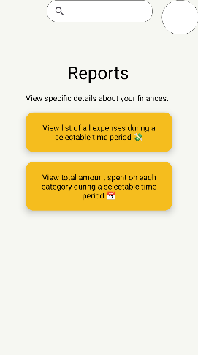

### Viewing Expense Entries

## Viewing Category Page

# Tech Stack

* **Platform**: Android
* **Language**: Kotlin
* **Development Environment**: Android Studio
* **Database**: Room Database

# Acknowledgements

**Used for adding specific colours for Features:** *Color Hunt - Color Palettes for Designers and Artists*. (n.d.). Retrieved from Color Hunt: https://colorhunt.co/palette/1235243e7b2785a947efe3c2

**Used for integrating RoomDB:** Ranju, S. (2024, January 18). *Step-by-Step: Setting Up and Implementing Room Database in Android*. Retrieved from Medium: https://medium.com/@sdranju/step-by-step-how-to-setting-up-and-implementing-room-database-aeb211c56702

# GitHub Link

<https://github.com/VCWVL/prog7313-part-2-ST10261605.git>